Bug Findings

Dt: 26/09/2026
- All page must have burger menu & Logo with link that direct to home page.
  - Header sequence must be Back button , Burger Menu , Logo.
  - Pages to make changes Home, manual-entry, employee, new saathi
- First loading screen not showing properly - Done
- 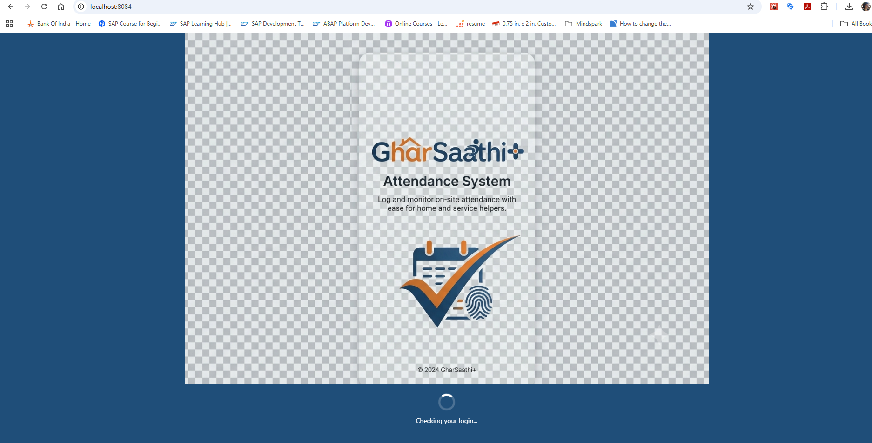
- Increase logo size
- 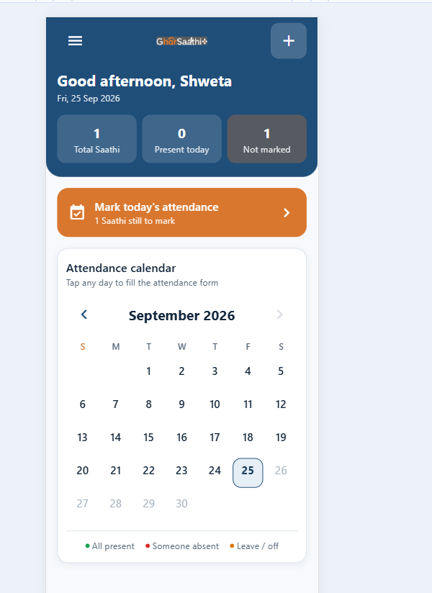
- Employee list have working emp available still in attendance entry showing no saathi - Done
- On burger menu header sequence as below: -- Done
  - Logo
  - Profile “S” with name and number
- 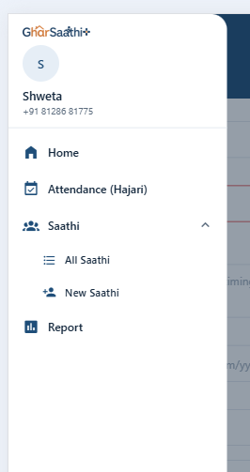

Dt: 28/09/2026
- Attendance list page --DONE
  - Make “Period” combo box smaller and put it beside Filter header set for mobile resolution of 440 * 956
  - Custom date filter should allow to select any date in both from & to date.
  - Default value for custom date filter is from 7 days before current date to today.
- Re-arrange menu as follow:
  - Home
  - Saathi
    - New Saathi
    - All Saathi
  - Hajari (Attendance)
    - Add Hajari (Attendance)
    - List
  - Report
- On “Add Saathi”, saving Saathi successfully must move cursor to Name field.

